COPR : CUSTOM AUTOSHOP PLATFORM

21CSC205P Database Management Systems
A MINI PROJECT REPORT

Submitted by
HARESHWAR S [RA2411051010037] TANYAA RP [RA2411051010033]

Under the Guidance of
Ms.ANNAPOORANI S
(Associate Professor, Department of data science and business systems)

in partial fulfillment of the requirements for the degree of
BACHELOR OF TECHNOLOGY
in
COMPUTER SCIENCE ENGINEERING
with specialization in (GAMING TECHNOLOGY)


DEPARTMENT OF DATA SCIENCE AND BUSINESS SYSTEM

SCHOOL OF COMPUTING
COLLEGE OF ENGINEERING AND TECHNOLOGY SRM INSTITUTE OF SCIENCE AND TECHNOLOGY KATTANKULATHUR- 603 203

MAY 2026

SRM INSTITUTE OF SCIENCE AND
TECHNOLOGY KATTANKULATHUR – 603 203

BONAFIDE CERTIFICATE

Certified that Project report titled “COPR:CUSTOM AUTOSHOP PLATFORM” is the bonafide work of “ HARESHWAR S
[RA2411051010037],TANYAA RP [RA2411051010033]” who carried out the
21CSC205P Database Management Systems mini project work under my supervision.

S ANNAPOORANI
ASSISTANT PROFESSOR
DEPARTMENT OF DATA SCIENCE AND BUSINESS SYSTEM
HEAD OF THE DEPARTMENT DEPARTMENT OF DATA SCIENCE AND BUSINESS SYSTEM
ABSTRACT

COPR – Custom Autoshop Platform is a comprehensive Database Management System designed to manage the operations of a multi-branch automobile workshop environment. The system integrates vehicle customization, service management, inventory control, supplier tracking, taxation handling, and security mechanisms within a unified relational database structure.

The platform separates customization and service workflows to ensure clarity in billing, resource allocation, and operational tracking. It supports tier-based and vehicle-type-dependent pricing, multi-dimensional tax computation based on vehicle type, modification category, and branch location, and an inventory reservation mechanism for pending customization orders. Multi-branch operations are modeled with dedicated warehouses under each branch, enabling stock transfers and supplier comparison between central and local vendors.

Security is implemented using role-based access control, login auditing, and account locking after multiple failed attempts. The database schema is normalized up to Third Normal Form (3NF) to eliminate redundancy and maintain referential integrity. Many-to-many relationships are resolved using associative entities to ensure consistency and scalability.

Overall, COPR demonstrates an enterprise-oriented relational database design capable of supporting real-world autoshop operations while maintaining data integrity, performance efficiency, and analytical capabilities.
TABLE OF CONTENTS

Chapter No. | Title | Page No.
 | ABSTRACT | 3
1 | Problem understanding, Identification of Entity and Relationships, Construction of DB using ER Model | 7
2 | Design of Relational Schemas, Creation of Database and Tables for their project | 11
3 | Complex queries based on the concepts of constraints, sets, joins, views, Triggers and Cursors. | 21
4 | Analyzing the pitfalls,Identifying the Dependencies and applying Normalizations. | 35
5 | Implementation of concurrency control and recovery mechanisms.
6 | Front-end And Back-End Implementation code
7 | Results and Discussions

LIST OF FIGURES

Figure No. | Name | Page no.
1.1 | ER Model | 8
2.1 | Relational Schema | 9

LIST OF TABLES
Table 2.1: Entity Description Table 15
Table 2.2: Relational Schema Overview 16
Table 3.1: Role Table Structure 20
Table 3.2: User Table Structure 21
Table 3.3: Customer Table Structure 22
Table 3.4: Vehicle and Vehicle_Type Tables 23
Table 3.5: Customization_Order Table 24
Table 3.6: Service_Order Table 25
Table 3.7: Inventory and Supplier Tables 26
Table 3.8: Tax and Order_Tax_Breakdown Tables 27
Table 5.1: UNF Representation 57
Table 5.2: First Normal Form (1NF) Structure 59
Table 5.3: Second Normal Form (2NF) Structure 61
Table 5.4: Third Normal Form (3NF) Structure 63
Table 5.5: Higher Normal Forms (BCNF / 4NF / 5NF) 65

CHAPTER 1

PROBLEM UNDERSTANDING, IDENTIFICATION OF ENTITY AND RELATIONSHIPS, CONSTRUCTION OF DB USING ER MODEL FOR THE COPR – CUSTOM AUTOSHOP PLATFORM

Introduction
The automobile service and customization industry involves complex operations such as vehicle servicing, modification management, inventory tracking, and billing. Many small and medium workshops still rely on manual processes or basic software systems, which often lead to data inconsistency, inefficient workflow management, and lack of transparency in pricing and inventory usage.
COPR (Custom Autoshop Platform) is designed as a database-driven system that integrates multiple operational modules including customer management, vehicle tracking, customization services, inventory handling, and taxation. The system aims to streamline workshop operations by maintaining structured data, improving accuracy, and enabling efficient decision-making.
By leveraging a well-designed relational database, COPR ensures proper handling of multi-branch operations, supplier management, and service workflows, making it a scalable and reliable solution for modern autoshops.

Motivation
The motivation behind COPR comes from the challenges faced by automobile workshops in managing customization and service operations effectively. Traditional systems often lack proper structure, leading to issues such as incorrect billing, poor inventory tracking, and inefficient handling of multiple customer requests.
Additionally, customization services involve complex pricing that depends on vehicle type, modification type, and service level. Without a structured database system, maintaining such dependencies becomes difficult and error-prone.
COPR is motivated by the need to create a centralized, secure, and normalized database system that can handle multiple operations efficiently while ensuring data consistency and accuracy. The project aims to demonstrate how database design principles can be applied to solve real-world business problems.

Scope
The scope of COPR includes the design and implementation of a database system that supports:
- Customer and user management with role-based access
- Vehicle registration and tracking
- Customization order processing with tier-based pricing
- Service order management and mechanic assignment
- Inventory management with supplier tracking
- Multi-branch operations with warehouse support
- Tax calculation and billing breakdown
The system focuses on backend database design and logic implementation. Advanced features such as mobile applications, real-time analytics, and AI-based recommendations are considered future enhancements and are outside the current scope.

Problem Statement
Traditional automobile workshop management systems are often manual or poorly structured, leading to inefficiencies in handling customer orders, inventory tracking, and service management. These systems fail to properly manage complex relationships such as customization pricing, multi-branch operations, and inventory dependencies.
The problem is to design a structured relational database system that can efficiently manage customer data, vehicle information, customization and service orders, inventory operations, and taxation, while ensuring data integrity, scalability, and consistency.

Project Requirements

Hardware Requirements:
- Personal Computer or Laptop
- Minimum 4GB RAM

Software Requirements:
- Database Management System (MySQL)
- SQL Interface / MySQL Command Line / Workbench
- Operating System (Windows / Linux)

Identification of Entities and Relationships

Entities
- User: Stores login credentials and role-based access
- Role: Defines different system roles such as admin, mechanic, and customer
- Customer: Stores customer details
- Vehicle: Contains vehicle information linked to customers
- Vehicle_Type: Defines types of vehicles (SUV, Sedan, etc.)
- Modification: Represents customization categories
- Modification_Tier: Defines levels of modification
- Customization_Order: Stores customer customization requests
- Service_Order: Stores service-related operations
- Mechanic: Contains mechanic details and availability
- Inventory: Stores parts and stock details
- Supplier: Stores supplier information
- Branch: Represents different workshop locations
- Warehouse: Stores inventory per branch
- Tax: Stores tax rules and percentages

Relationships
- A User is assigned a Role
- A Customer is linked to a User
- A Customer owns multiple Vehicles
- A Vehicle belongs to one Vehicle_Type
- A Customer places Customization_Orders
- A Customization_Order includes multiple Modifications
- A Vehicle undergoes Service_Orders
- A Mechanic is assigned to multiple Service_Orders
- A Supplier supplies Inventory
- A Branch manages Service_Orders and Inventory
- Tax is applied to Customization_Orders

Construction of DB Using ER Model for COPR – Custom Autoshop Platform

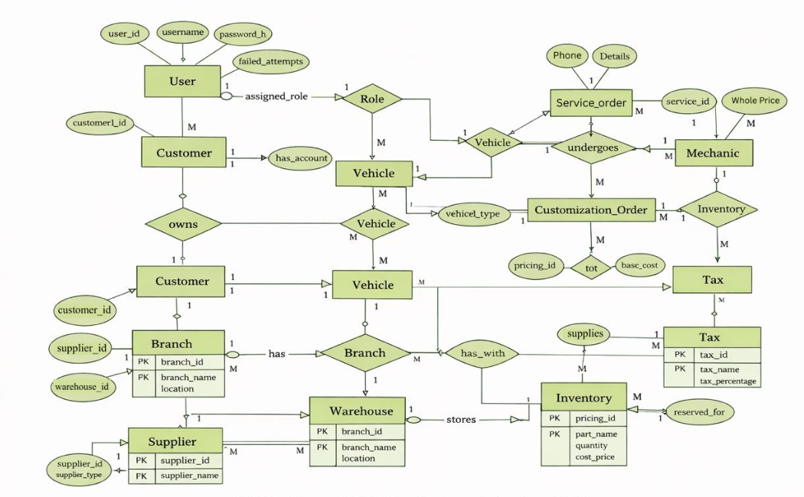

CHAPTER 2: SYSTEM ANALYSIS AND DESIGN

Conceptual ER Model
The conceptual design of the COPR system is represented using Chen Notation. The ER model visually describes the major entities, their attributes, and the relationships between them.
The main entities identified in the system are:
    - User

    - Role

    - Customer

    - Vehicle

    - Vehicle_Type

    - Customization_Order

    - Modification

    - Modification_Tier

    - Service_Order

    - Mechanic

    - Inventory

    - Supplier

    - Branch

    - Warehouse

    - Tax

Each entity is represented as a rectangle, attributes are shown using ovals, and relationships are represented using diamonds. Primary keys are underlined to indicate unique identification of records.
The ER model clearly separates the customization and service modules to maintain clarity in workflow and billing processes.
(Insert Figure 1.1: ER Model here)

ER Diagram Explanation
The ER diagram demonstrates the relationships among entities in the COPR system.
    - A User is assigned a specific Role.

    - A Customer is associated with exactly one User account.

    - A Customer can own multiple Vehicles.

    - Each Vehicle belongs to one Vehicle_Type.

In the customization module:
    - A Customer places a Customization_Order for a specific Vehicle.

    - Each order may include multiple Modification_Tiers.

    - Pricing depends on both the tier and vehicle type through the Tier_Vehicle_Pricing entity.

In the service module:
    - A Vehicle can have multiple Service_Orders.

    - Each Service_Order can contain multiple Service_Tasks.

    - Mechanics are assigned to service orders using a many-to-many relationship resolved by the Job_Assignment entity.

In the inventory module:
    - Each Branch contains one or more Warehouses.

    - Warehouses store Inventory items.

    - Inventory items are supplied by either central or local Suppliers.

    - Inventory can be reserved when a customization order is pending.

In the taxation module:
    - Tax is applied based on vehicle type, modification category, and branch location.

    - The Order_Tax_Breakdown entity records tax calculations for each order.
The ER model ensures proper normalization by resolving many-to-many relationships through associative entities such as:
    - Order_Modification

    - Job_Assignment

    - Inventory_Reservation

    - Order_Tax_Breakdown

Relational Schema
Based on the ER model, the system is converted into relational tables. Each entity becomes a table with a primary key, and relationships are implemented using foreign keys.
Major tables in the system include:
    - Role (role_id, role_name)

    - User (user_id, username, password_hash, role_id, account_status)

    - Customer (customer_id, user_id)

    - Vehicle (vehicle_id, customer_id, vehicle_type_id, registration_number)

    - Customization_Order (order_id, customer_id, vehicle_id, branch_id, order_status, created_at)

    - Service_Order (service_id, vehicle_id, branch_id, service_status, created_at)

    - Inventory (inventory_id, warehouse_id, supplier_id, part_name, quantity, cost_price)

    - Tax (tax_id, tax_name, tax_percentage, applicable_vehicle_type, applicable_category, applicable_branch)

All foreign key constraints are defined to maintain referential integrity between tables.

Design Considerations
The following design principles were considered while developing the database:
    - Elimination of redundancy through normalization

    - Clear separation of customization and service workflows
    - Support for multi-branch operations

    - Secure role-based access control

    - Support for analytical queries such as profit calculation and tax reports

    - Scalability for future expansion

The system design ensures consistency, efficiency, and maintainability.

CHAPTER 3
COMPLEX QUERIES BASED ON CONSTRAINTS, SETS, JOINS, VIEWS, TRIGGERS AND CURSORS FOR COPR – CUSTOM AUTOSHOP PLATFORM

Adding Constraints and Queries Based on Constraints

Question 1:
Add a constraint to ensure inventory quantity cannot be negative.

SQL Statement:
ALTER TABLE Inventory
ADD CONSTRAINT chk_quantity_positive
CHECK (quantity >= 0);

Output:
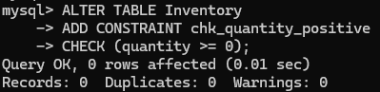

Question 2:
Add a unique constraint to ensure no two suppliers have the same name.

SQL Statement:
ALTER TABLE Supplier
ADD CONSTRAINT unique_supplier_name
UNIQUE (supplier_name);

Output:
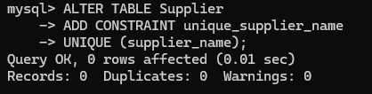

Question 3:
Attempt to insert invalid inventory data to test constraint.

SQL Statement:
INSERT INTO Inventory (inventory_id, warehouse_id, supplier_id, part_name, quantity, cost_price)
VALUES (99, 1, 1, 'Test Part', -5, 1000);

Output:

Queries Based on Aggregate Functions

Question 1:
Find total number of customization orders per customer.

SQL Statement:
SELECT customer_id, COUNT(*) AS total_orders
FROM Customization_Order
GROUP BY customer_id;

Output:
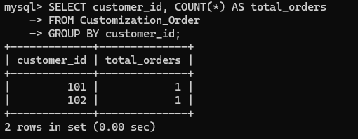

Question 2:
Find total inventory quantity per warehouse.

SQL Statement:
SELECT warehouse_id, SUM(quantity) AS total_stock
FROM Inventory
GROUP BY warehouse_id;

Output:
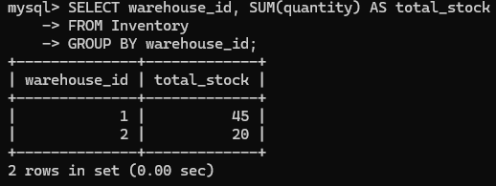

Question 3:
Find average pricing for each vehicle type.

SQL Statement:
SELECT vehicle_type_id, AVG(selling_price) AS avg_price
FROM Tier_Vehicle_Pricing
GROUP BY vehicle_type_id;

Output:
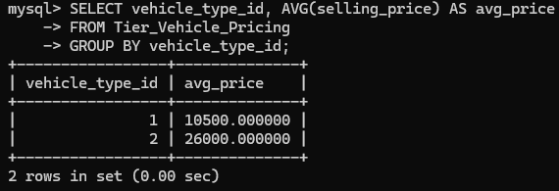

Complex Queries Based on Sets

Question 1:
Retrieve combined list of supplier names and branch names.

SQL Statement:
SELECT supplier_name AS name FROM Supplier
UNION
SELECT branch_name FROM Branch;

Output:
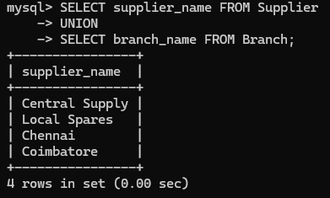

Question 2:
Find users who are customers and have placed orders.

SQL Statement:
SELECT c.user_id
FROM Customer c
JOIN Customization_Order o ON c.customer_id = o.customer_id;

Output:
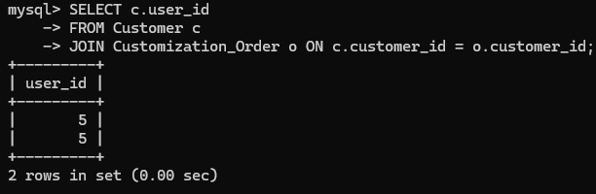

Question 3:
Find vehicles that exist but have no service orders.

SQL Statement:
SELECT vehicle_id
FROM Vehicle
WHERE vehicle_id NOT IN
(SELECT vehicle_id FROM Service_Order);

Output:
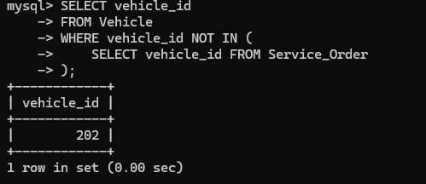

Complex Queries Based on Subqueries

Question 1:
Find inventory items with quantity greater than average.

SQL Statement:
SELECT part_name, quantity
FROM Inventory
WHERE quantity > (SELECT AVG(quantity) FROM Inventory);

Output:
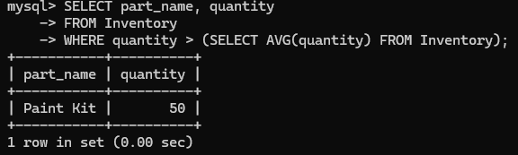

Question 2:
Find branches with more than one service order.

SQL Statement:
SELECT branch_id
FROM Service_Order
GROUP BY branch_id
HAVING COUNT(*) > 1;

Output:
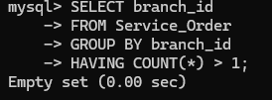

Question 3:
Find latest service order.

SQL Statement:
SELECT *
FROM Service_Order
WHERE created_at = (SELECT MAX(created_at) FROM Service_Order);

Output:
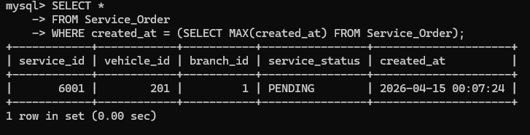

Complex Queries Based on Joins

Question 1:
Display customization orders with customer and vehicle details.

SQL Statement:
SELECT o.order_id, c.customer_id, v.registration_number
FROM Customization_Order o
JOIN Customer c ON o.customer_id = c.customer_id
JOIN Vehicle v ON o.vehicle_id = v.vehicle_id;

Output:
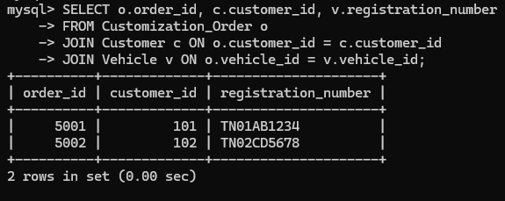

Question 2:
Show all inventory items with supplier details.

SQL Statement:
SELECT i.part_name, s.supplier_name, i.quantity
FROM Inventory i
JOIN Supplier s ON i.supplier_id = s.supplier_id;

Output:
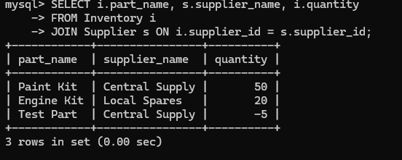

Question 3:
Show service orders with mechanic assignment.

SQL Statement:
SELECT so.service_id, m.mechanic_id, so.service_status
FROM Service_Order so
JOIN Job_Assignment ja ON so.service_id = ja.service_id
JOIN Mechanic m ON ja.mechanic_id = m.mechanic_id;

Output:
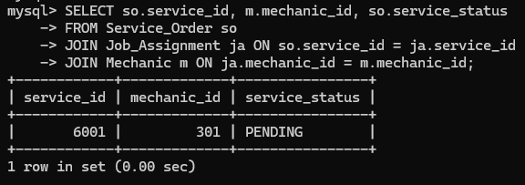

Complex Queries Based on Views

Question 1:
Create view for total orders per customer.

SQL Statement:
CREATE VIEW customer_order_summary AS
SELECT customer_id, COUNT(*) AS total_orders
FROM Customization_Order
GROUP BY customer_id;

Output:
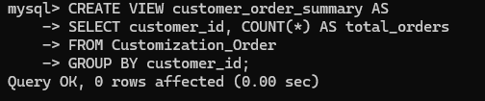
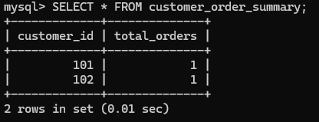

Question 2:
Create inventory summary view.

SQL Statement:
CREATE VIEW inventory_summary AS
SELECT warehouse_id, SUM(quantity) AS total_stock
FROM Inventory
GROUP BY warehouse_id;

Output:
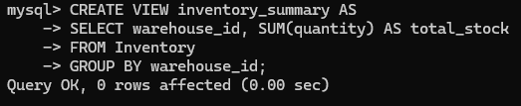
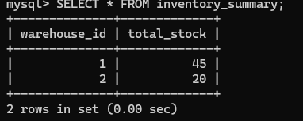

Question 3:
Query high stock warehouses.

SQL Statement:
SELECT * FROM inventory_summary
WHERE total_stock > 20;

Output:
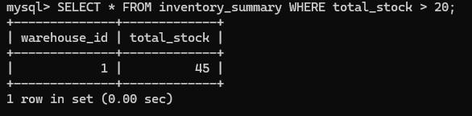

Complex Queries Based on Triggers

Question 1:
Create trigger to prevent negative inventory.

SQL Statement:
DELIMITER //
CREATE TRIGGER prevent_negative_inventory
BEFORE UPDATE ON Inventory
FOR EACH ROW
BEGIN
IF NEW.quantity < 0 THEN
SIGNAL SQLSTATE '45000'
SET MESSAGE_TEXT = 'Quantity cannot be negative';
END IF;
END //
DELIMITER ;

Output:

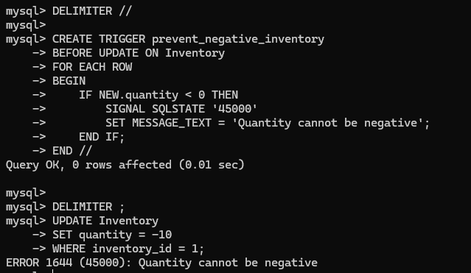

Question 2:
Create audit table and trigger for orders.

SQL Statement:
CREATE TABLE Order_Audit (
audit_id INT AUTO_INCREMENT PRIMARY KEY,
order_id INT,
created_at DATETIME DEFAULT CURRENT_TIMESTAMP
);

DELIMITER //
CREATE TRIGGER log_order
AFTER INSERT ON Customization_Order
FOR EACH ROW
BEGIN
INSERT INTO Order_Audit(order_id) VALUES (NEW.order_id);
END //
DELIMITER ;

Output:
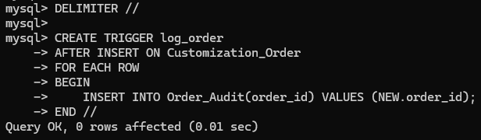

Question 3:
Test trigger functionality.

SQL Statement:
INSERT INTO Customization_Order VALUES (6000,101,201,1,'PENDING',NOW());
SELECT * FROM Order_Audit;

Output:


Complex Queries Based on Cursors

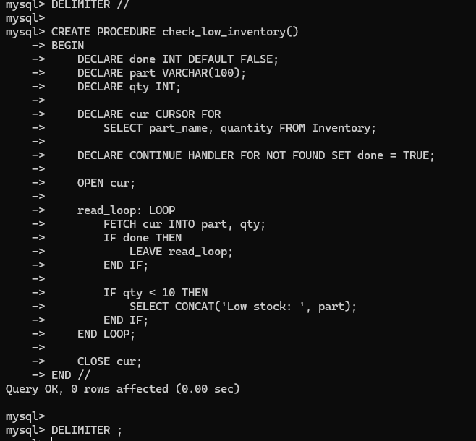

CHAPTER 4

PROGRAM: NORMALIZATION USING EXISTING TABLES

4.1 Analyse the Pitfalls in Relations

SQL Statement:
SELECT customer_id, vehicle_id, branch_id
FROM Customization_Order;

Output:
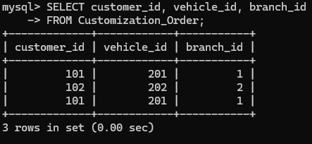

Explanation:
The same customer, vehicle, and branch data may appear multiple times across different orders, leading to redundancy and possible update inconsistencies.

4.2 First Normal Form (1NF)

SQL Statement:
SELECT * FROM Order_Modification;

Output:
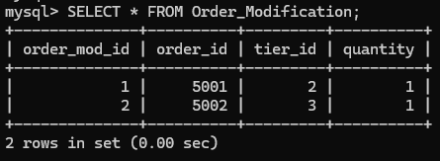

Explanation:
First Normal Form ensures that all attributes contain atomic values and no repeating groups. Each modification is stored as a separate row, ensuring data is indivisible.

4.3 Second Normal Form (2NF)

SQL Statement:
SELECT * FROM Tier_Vehicle_Pricing;

Output:
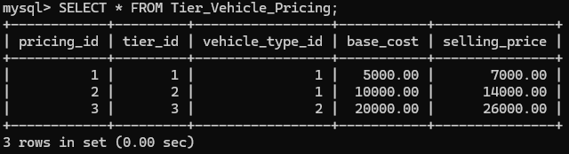

Explanation:
Second Normal Form removes partial dependency. All non-key attributes depend on the full primary key, such as pricing depending on both vehicle type and modification tier.

4.4 Third Normal Form (3NF)

SQL Statement:
SELECT * FROM Branch;
SELECT * FROM Supplier;
SELECT * FROM Vehicle_Type;

Output:
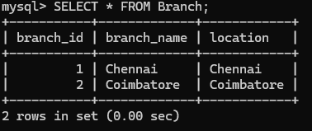
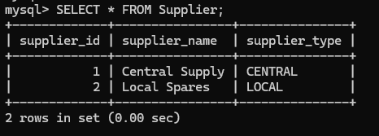
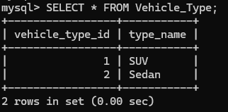

Explanation:
Third Normal Form removes transitive dependency. Attributes like branch_name and supplier_name depend only on their primary keys and not on other non-key attributes.

4.5 Boyce-Codd Normal Form (BCNF)

SQL Statement:
DESCRIBE Customization_Order;

Output:
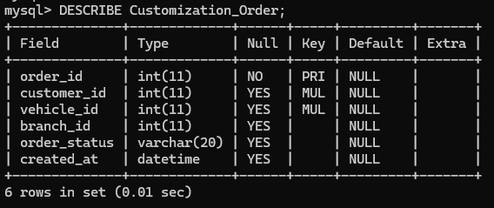

Explanation:
BCNF ensures that every determinant is a candidate key. All attributes in the table are fully dependent on the primary key without any anomalies.

4.6 Fourth Normal Form (4NF)

SQL Statement:
SELECT * FROM Order_Modification;
SELECT * FROM Inventory_Reservation;

Output:
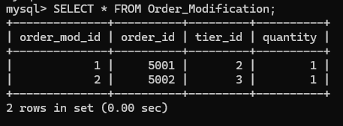
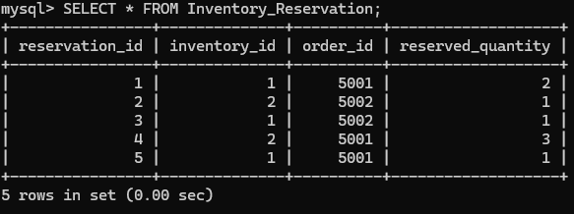

Explanation:
Fourth Normal Form eliminates multi-valued dependencies. Multiple modifications and inventory reservations are stored in separate tables to avoid duplication.

4.7 Fifth Normal Form (5NF)

SQL Statement:
SELECT o.order_id, c.customer_id, v.vehicle_id
FROM Customization_Order o
JOIN Customer c ON o.customer_id = c.customer_id
JOIN Vehicle v ON o.vehicle_id = v.vehicle_id;

Output:
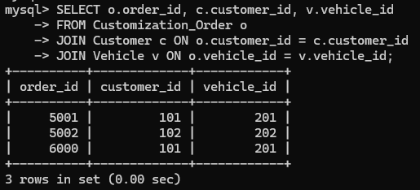

Explanation:
Fifth Normal Form ensures that data can be decomposed into smaller tables and reconstructed using joins without loss of information.

CHAPTER 5

IMPLEMENTATION OF CONCURRENCY CONTROL AND RECOVERY MECHANISMS

5.1 Introduction to Transactions

5.1.1 Properties

Atomicity – All operations in a transaction either complete fully or fail entirely.
Consistency – The database remains valid before and after the transaction.
Isolation – Transactions execute independently without interference.
Durability – Once committed, changes are permanently stored.

5.1.2 States

Active
Partially Committed
Committed
Failed

5.2 Transaction Control Language (TCL)

5.2.1 Savepoint

SQL Statement:
SAVEPOINT sp1;

Output:
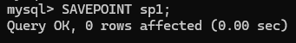

5.2.2 Commit

SQL Statement:
COMMIT;

Output:


5.2.3 Rollback

SQL Statement:
ROLLBACK;

Output:
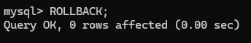

5.3 Transactions

5.3.1 Transaction 1

SQL Statement:
START TRANSACTION;
INSERT INTO Customer VALUES (999, 1);
COMMIT;

Output:
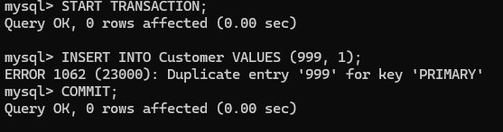

Transaction 2

SQL Statement:
START TRANSACTION;
UPDATE Inventory
SET quantity = quantity - 2
WHERE inventory_id = 1;
COMMIT;

Output:
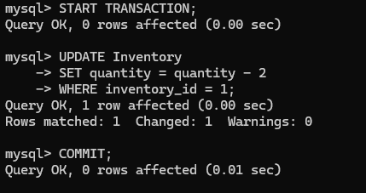

Transaction 3

SQL Statement:
START TRANSACTION;
INSERT INTO Customization_Order VALUES (7000,101,201,1,'PENDING',NOW());
ROLLBACK;

Output:
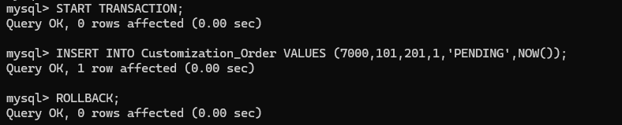

Transaction 4

SQL Statement:
START TRANSACTION;
UPDATE Service_Order
SET service_status = 'COMPLETED'
WHERE service_id = 1;
SAVEPOINT sp1;
UPDATE Service_Order
SET service_status = 'FAILED'
WHERE service_id = 1;
ROLLBACK TO sp1;
COMMIT;

Output:
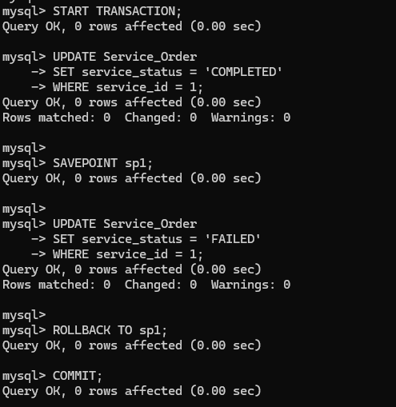

Transaction 5

SQL Statement:
START TRANSACTION;
INSERT INTO Inventory_Reservation VALUES (10,1,5001,2);
COMMIT;

Output:
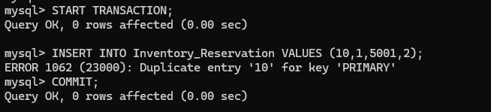

5.3 Concurrency Control

5.3.1 Locking Commands

a. Row-Level Locking

SQL Statement:
START TRANSACTION;
SELECT * FROM Inventory
WHERE inventory_id = 1
FOR UPDATE;
COMMIT;

Output: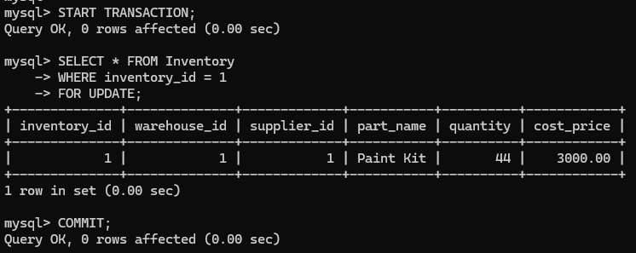

b. Table-Level Locking

SQL Statement:
LOCK TABLES Inventory WRITE;
UNLOCK TABLES;

Output:
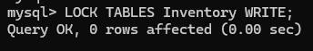
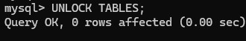

5.3.2 Example

SQL Statement:
START TRANSACTION;
UPDATE Inventory
SET quantity = quantity - 1
WHERE inventory_id = 1;
SELECT * FROM Inventory WHERE inventory_id = 1;
COMMIT;

Output:
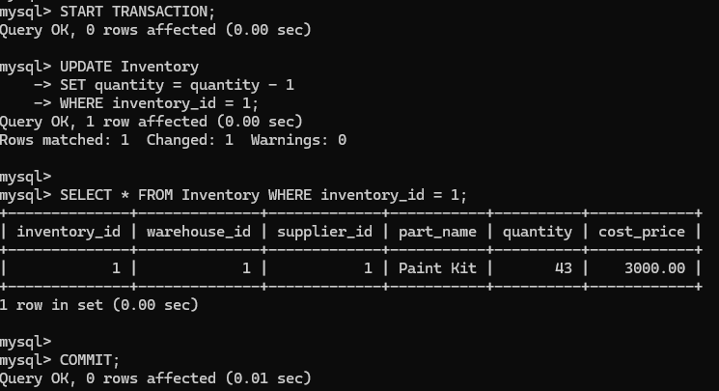

CONCLUSION
The COPR – Custom Autoshop Platform successfully demonstrates the design and implementation of a structured relational database system for managing multi-branch automobile workshop operations. The system effectively integrates customization management, service workflows, inventory tracking, supplier handling, taxation logic, and security mechanisms within a unified database architecture.
By separating customization and service modules, the system ensures clarity in operational flow and billing. The implementation of tier-based and vehicle-type-dependent pricing improves flexibility and scalability.
The inventory reservation mechanism enhances consistency during order confirmation, while transaction control ensures reliable data processing in a multi-user environment.
Normalization techniques were applied to eliminate redundancy and maintain data integrity. Many-to-many relationships were resolved using associative entities, ensuring compliance with Third Normal Form (3NF). The use of foreign key constraints strengthens referential integrity across the database.
Security features such as role-based access control, login auditing, and account locking enhance system reliability and prevent unauthorized access.
Overall, the COPR database system provides a scalable, efficient, and well-structured solution for managing modern autoshop operations while demonstrating key database concepts including ER modeling, normalization, transaction management, and concurrency control.

REFERENCES:
- MySQL Documentation. (2023). MySQL 8.0 Reference Manual. Retrieved from https://dev.mysql.com/doc/
- W3Schools. (2023). SQL Tutorial. Retrieved from https://www.w3schools.com/sql/
- Oracle Corporation. (2023). Database Concepts Guide. Retrieved from https://docs.oracle.com/

